How the world makes electricity
Hŷpercast tool showcase · handout

Four equations
In 1865 James Clerk Maxwell wrote four equations that explain every motor, generator and power line, and predict light. Three maths engines here (SymPy, SageMath, Maxima) each derive c = 1/√(μ₀ε₀) = 299,792,458 m/s.
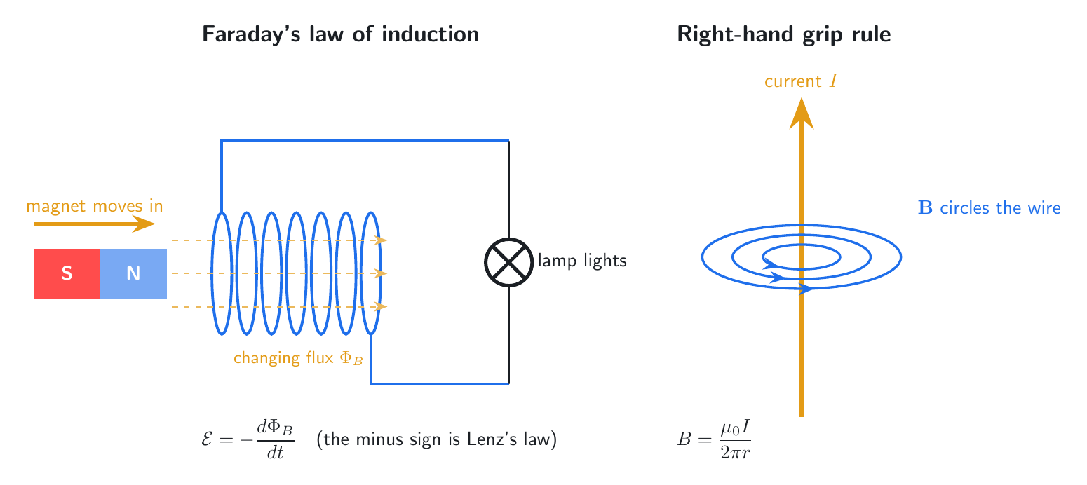
Faraday’s law and the right-hand rule (TikZ)

Make
Almost every power station spins a magnet inside coils of wire.
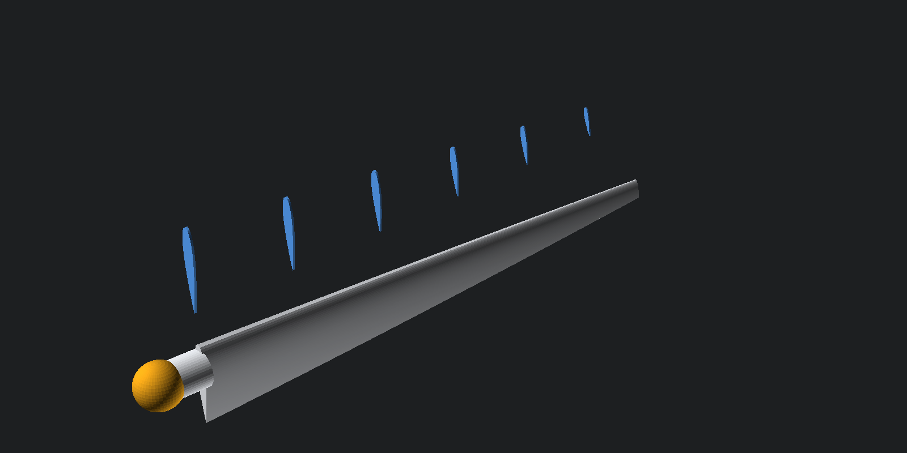
Wind turbine blade, parametric (OpenSCAD)

Move
Transformers raise the voltage for distance and lower it for homes. Inverters turn solar and battery DC into AC.
How a transformer works (Excalidraw)

Mix
In 2025 the world made 31,772 TWh of electricity: coal 33%, gas 22%, hydro 14%, nuclear 9%, wind 8.5%, solar 8.7%.

Store
Lithium-ion batteries hold lithium between layers of cobalt oxide.
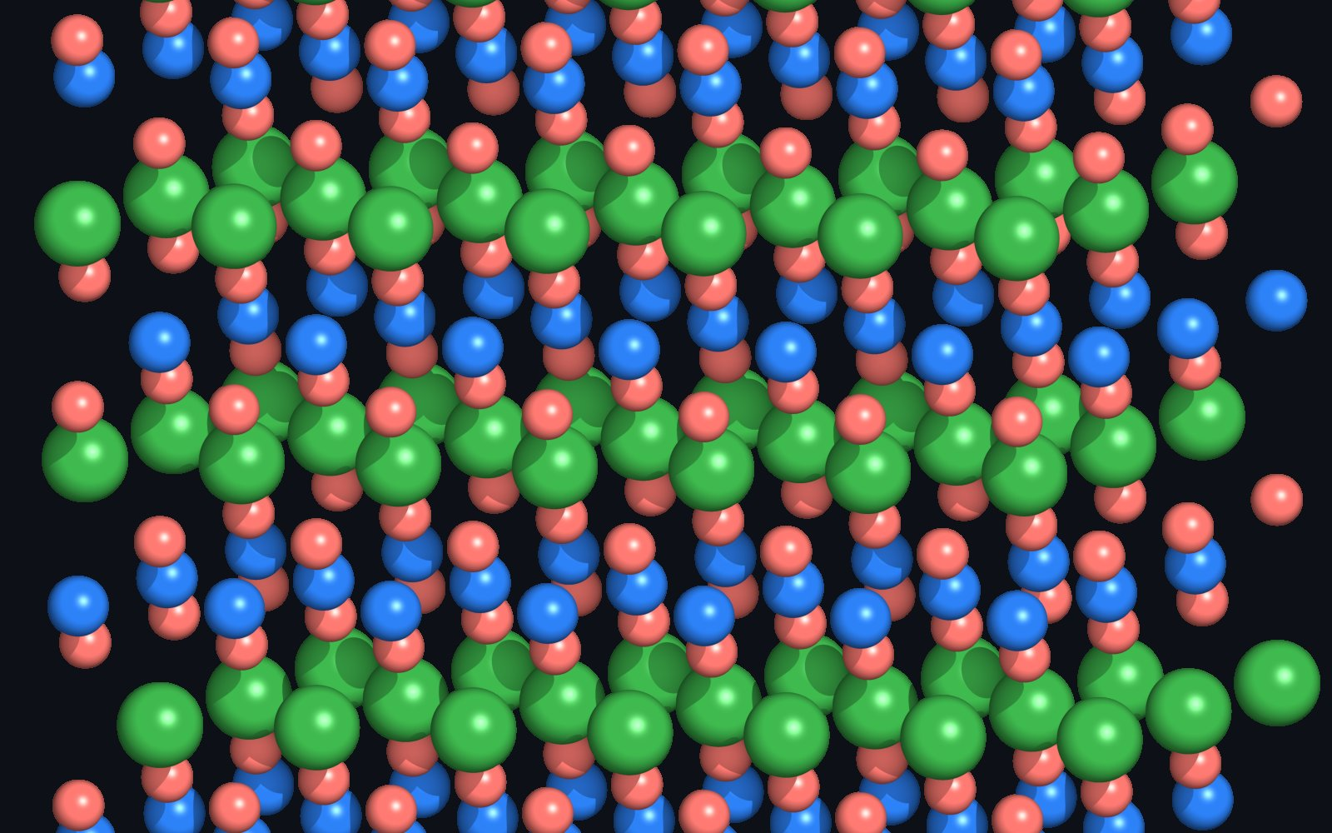
LiCoO₂ crystal (PyMOL)

Sources
- Our World in Data, energy dataset (CC BY 4.0)
- WRI Global Power Plant Database v1.3 (CC BY 4.0)

